Congratulations to the following student-athletes for their selection as

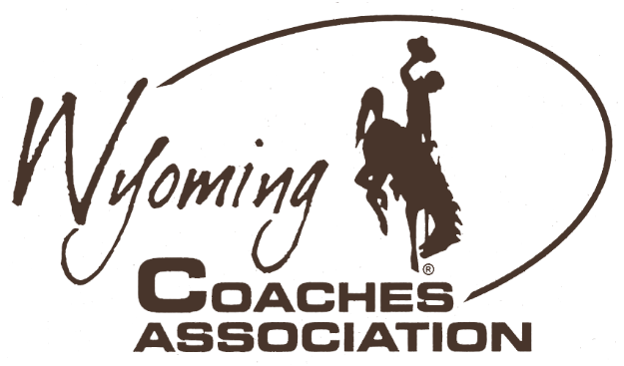
2023 Wyoming Coaches Association All-State Basketball
Ryan Mader, President
Larry Yeradi, Executive Secretary
307-620-1325
• Buffalo
307-680-2628
• Wright
rmader@jcsd1.us
wcawcf1922@gmail.com
Jessica Nugent, President Elect
Walt Smith, Executive Director
307-371-1344
• Big Piney
307-534-6815
• Torrington
jnugent@sublette9.org
WSmith@goshen1.org
Dean Schaff, Past President
Matt Mason, Presidential Secretary
307-349-9573
• Lander
307-921-8537
• Riverton
dschaff@landerschools.org
mmason@fremont25.org
1A Girls |  |  |  |  | 1A Boys
Name |  | School |  | Name |  | School
Kelsi Nicholson |  | Burlington |  | Carson Jones |  | Burlington
Mia Dayton |  | Cokeville |  | Seth Wardell |  | Burlington
Addison Barnes |  | Cokeville |  | Grant Winters |  | Burlington
Maren Baker |  | Dubois |  | Justin Moyes |  | Cokeville
Cora Schroeder |  | Encampment |  | Ryan Wells |  | Dubois
Caroline Schlattmann |  | Riverside |  | Hadley Myers |  | Little Snake River
Naomi Moore |  | Rock River |  | Ethan Schiller |  | Upton
Whitney Bennett |  | Saratoga |  | Chase Mills |  | Upton
Sidney Anderson |  | Southeast |  | Grady Bartlett |  | Saratoga
Brenna Herring |  | Southeast |  | Grant Bartlett |  | Saratoga
Kealy Carson |  | Southeast |  | Finn Rolseth |  | Saratoga
Sophie Louderback |  | Upton |  | Jack Dayton |  | Cokeville
Brooklyn Materi |  | Upton |  | Ayden Desmond |  | Southeast
Paige Timberman |  | Upton |  | Austin Short |  | Southeast
WCA guidelines state that current WCA member coaches may nominate and vote for All-State awards. All nominees must be 1st Team All-Conference selections. The WCA is not responsible for any criteria or selection process used in selecting All-Conference awards. Criteria for All-State selection is left up to the sport association. 14 student-athletes in each classification are awarded Wyoming Coaches Association All-State Basketball.
Congratulations to the following student-athletes for their selection as

2023 Wyoming Coaches Association All-State Basketball
Ryan Mader, President
Larry Yeradi, Executive Secretary
307-620-1325
• Buffalo
307-680-2628
• Wright
rmader@jcsd1.us
wcawcf1922@gmail.com
Jessica Nugent, President Elect
Walt Smith, Executive Director
307-371-1344
• Big Piney
307-534-6815
• Torrington
jnugent@sublette9.org
WSmith@goshen1.org
Dean Schaff, Past President
Matt Mason, Presidential Secretary
307-349-9573
• Lander
307-921-8537
• Riverton
dschaff@landerschools.org
mmason@fremont25.org
2A Girls |  |  | 2A Boys
Name | School |  | Name | School
Daljit Kaur | Burns |  | Toby Schons | Big Horn
Jordan Griess | Burns |  | Cooper Garber | Big Horn
Natalie Speckner | Lingle Ft. Laramie |  | Jovany Munoz | Big Piney
Ashlee Hattan | Lingle Ft. Laramie |  | Carlos Rodriguez | Greybull
Jessica Hoffman | Pine Bluffs |  | Jake Kampman | Kemmerer
Mackelle Moss | Rocky Mountain |  | Ryan Fornstrom | Pine Bluffs
Victoria Arnold | Rocky Mountain |  | Stu Lerwick | Pine Bluffs
Hailey Donelson | Shoshoni |  | Ben Simmons | Rocky Mountain
Jaylin Mills | Sundance |  | Alex Mills | Shoshoni
Lexie Marchant | Sundance |  | Colter Hanft | Tongue River
McKinlee Skammon | Tongue River |  | Caleb Kilbride | Tongue River
Chaney Reish | Tongue River |  | Parker Worman | Wright
Shye Killsontop | Wyoming Indian |  | Jaycee Herbert | Wind River
Elianna Duran | Wyoming Indian |  | Wylie Shearer | Wind River
WCA guidelines state that current WCA member coaches may nominate and vote for All-State awards. All nominees must be 1st Team All-Conference selections. The WCA is not responsible for any criteria or selection process used in selecting All-Conference awards. Criteria for All-State selection is left up to the sport association. 14 student-athletes in each classification are awarded Wyoming Coaches Association All-State Basketball.

