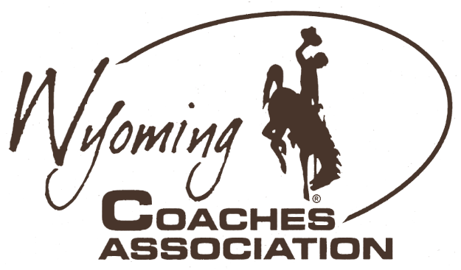
Ryan Mader, President
Larry Yeradi, Executive Secretary
307-620-1325
• Buffalo
307-680-2628
• Wright
rmader@jcsd1.us
wcawcf1922@gmail.com
Jessica Nugent, President Elect
Walt Smith, Executive Director
307-371-1344
• Big Piney
307-534-6815
• Torrington
jnugent@sublette9.org
WSmith@goshen1.org
Dean Schaff, Past President
Matt Mason, Presidential Secretary
307-349-9573
• Lander
307-921-8537
• Riverton
dschaff@landerschools.org
mmason@fremont25.org
Congratulations to the following student-athletes for their selection as
2023 Wyoming Coaches Association All-State Basketball
3A Girls |  |  |  | 3A Boys
Name |  | School |  | Name |  | School
Karly Davis |  | Buffalo |  | Eli Patterson |  | Buffalo
Grace Peterson |  | Buffalo |  | Levi Curtis |  | Douglas
Cantrell Rosalez |  | Buffalo |  | Nate Halquist |  | Douglas
Tess Rule |  | Buffalo |  | Jackson Hughes |  | Douglas
Lauren Olsen |  | Douglas |  | Trey Rinn |  | Douglas
Brooke Wright |  | Douglas |  | Brenon Stauffenberg |  | Lander
Julia Sarvey |  | Glenrock |  | Joel Padilla |  | Lovell
Sage Bradshaw |  | Lyman |  | Braydon Bradshaw |  | Lyman
McKinlee Covoloe |  | Mountain View |  | McKoy Smith |  | Lyman
Jaylen Ostenson |  | Newcastle |  | Josh Gosar |  | Pinedale
Shelby Tidyman |  | Newcastle |  | Brock Johnson |  | Powell
Elyn Bowers |  | Pinedale |  | Carter Clark |  | Worland
Addy Thorington |  | Powell |  | Brock Douzenis |  | Worland
Lily Nichols |  | Wheatland |  | Court Gonsalez |  | Worland
WCA guidelines state that current WCA member coaches may nominate and vote for All-State awards. All nominees must be 1st Team All-Conference selections. The WCA is not responsible for any criteria or selection process used in selecting All-Conference awards. Criteria for All-State selection is left up to the sport association. 14 student-athletes in each classification are awarded Wyoming Coaches Association All-State Basketball.

