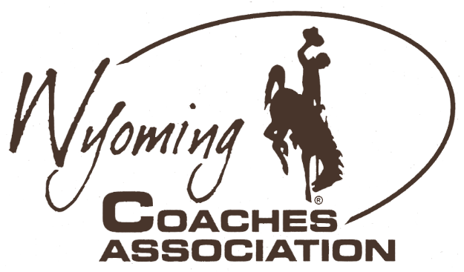
Ryan Mader, President
Larry Yeradi, Executive Secretary
307-620-1325
• Buffalo
307-680-2628
• Wright
rmader@jcsd1.us
wcawcf1922@gmail.com
Jessica Nugent, President Elect
Walt Smith, Executive Director
307-371-1344
• Big Piney
307-534-6815
• Torrington
jnugent@sublette9.org
WSmith@goshen1.org
Dean Schaff, Past President
Matt Mason, Presidential Secretary
307-349-9573
• Lander
307-921-8537
• Riverton
dschaff@landerschools.org
mmason@fremont25.org
Congratulations to the following student-athletes for their selection as
2023 Wyoming Coaches Association All-State Alpine Ski
Girls |  |  |  | Boys
Name |  | School |  | Name | School
Adaya Whitelock |  | Cody |  | Logan Ross | Cody
Ceci Bruno |  | Jackson Hole |  | Travis D’Amours | Jackson Hole
Madison Kramer |  | Jackson Hole |  | Owen Janssen | Jackson Hole
Annie Moll |  | Jackson Hole |  | Brett Lane | Jackson Hole
Taylor Smith |  | Jackson Hole |  | Adi Wetzler | Jackson Hole
Lily Steinberg |  | Jackson Hole |  | Kenny Lacko | Kelly Walsh
Lu Reed |  | Kelly Walsh |  | Gabin Bright | Natrona County
Aleka Blair |  | Natrona County |  | Jack Canepa | Natrona County
Evie Crawford |  | Natrona County |  | Cody Crawford | Natrona County
MK Lacko |  | Natrona County |  | James Tolson | Pinedale
[WCA guidelines honor the top 10 individuals based on the season’s race point totals using the format from the International World Cup as All-State]

