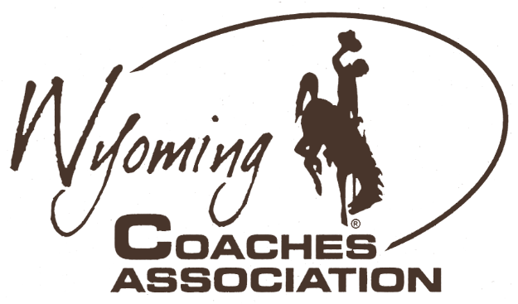
Ryan Mader, President
Larry Yeradi, Executive Secretary
307-620-1325
• Buffalo
307-680-2628
• Wright
rmader@jcsd1.us
wcawcf1922@gmail.com
Jessica Nugent, President Elect
Walt Smith, Executive Director
307-371-1344
• Big Piney
307-534-6815
• Torrington
jnugent@sublette9.org
WSmith@goshen1.org
Dean Schaff, Past President
Matt Mason, Presidential Secretary
307-349-9573
• Lander
307-921-8537
• Riverton
dschaff@landerschools.org
mmason@fremont25.org
Congratulations to the following student-athletes for their selection as
2023 Wyoming Coaches Association All-State Nordic Ski
Girls |  |  |  | Boys
Name |  | School |  | Name | School
Elisa Wachob |  | Cody |  | Sam Sinclair | Jackson Hole
Abigail Murphy |  | Jackson Hole |  | Fisk Johansson | Kelly Walsh
Aurora Stiles |  | Jackson Hole |  | Luke Pearson | Kelly Walsh
Emma Pearson |  | Kelly Walsh |  | Luke Schmidt | Kelly Walsh
Eleanor Veauthier |  | Kelly Walsh |  | Otus Beason | Lander
Emily Anderson |  | Lander |  | Bennett Hutchison | Lander
Shayla Babits |  | Lander |  | Diego Lobatos | Lander
Ameya Eddy |  | Lander |  | Emmitt Gray | Laramie
Divya Forbis |  | Lander |  | Jack Voos | Laramie
Eliza Fay |  | Laramie |  | Kalel Brubaker | Natrona County
[WCA guidelines honor the top 10 individuals based on the season’s race point totals using the format from the International World Cup as All-State]

